**Experiment No. 1.2**

**Student Name: Rishav Kumar UID: 22MCC20039**

**Branch: MCA - CCD Section/Group: MCD-1/ Grp A**

**Semester: II Date of Performance: 23rd Feb 23**

**Subject Name: Cloud Computing Lab Subject Code: 22CAP-687**

1. **Aim/Overview of the practical:**

Create a webpage and publish on Azure using File Explorer.

1. **Code for practical:**

* Open Azure Portal and click on “***Create WebApp”***. Provide Name and Select plan for WebApp.
* Now click on GitHub and select your repository.
* Select runtime stack to ASP.NET
* Select your server location and plan.

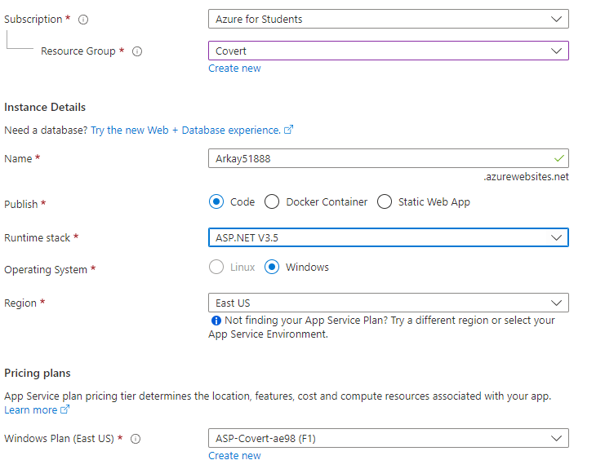

* Click on “***Review + Create”*** button to deploy your WebApp.

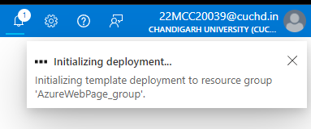

* It’ll take a minute or two to deploy your website.

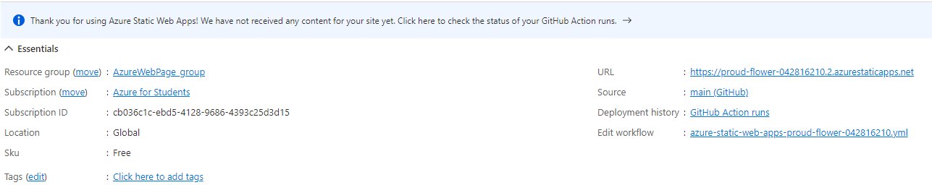

* Then click on ***Download Publish Profile***.
* Open the downloaded file and copy ftp address.
* Open This PC and paste the URL in path.
* Enter Username and password from the file.
* 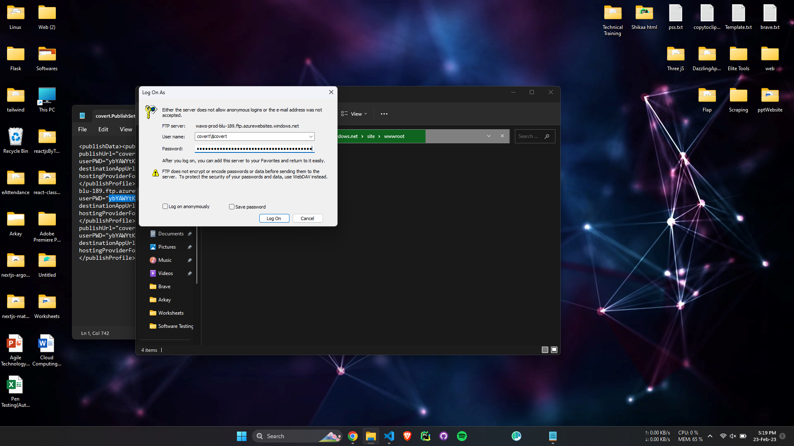
* Upload your website files in this directory.
* Website will be deployed within minutes.
* Click on ***Browse*** button or click on URL to view your deployed website on Azure Portal.

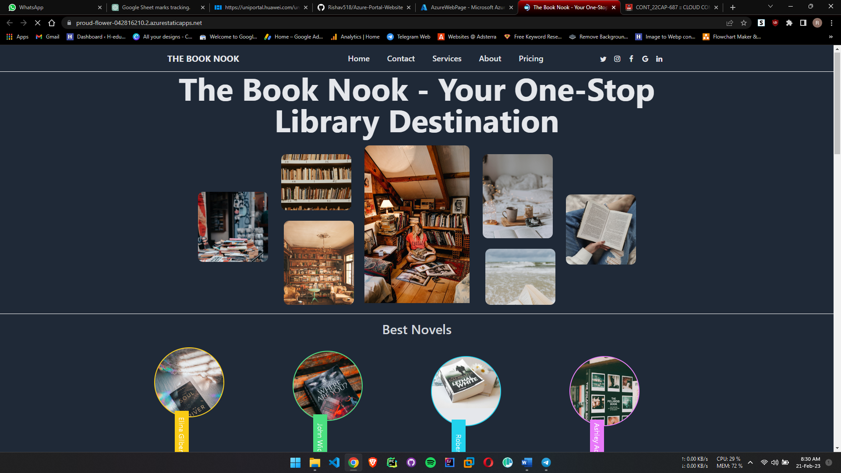

**************************************** **THE END** ***********************************************